Name: Tudorie Marius Cosmin

Second year, group 1065 G series.

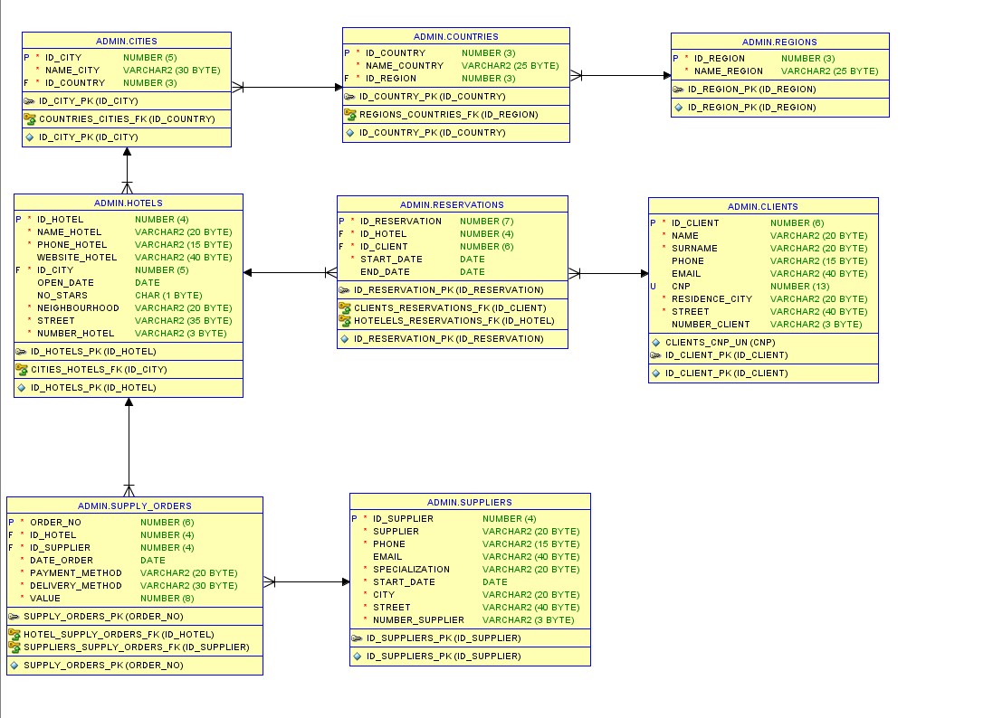Database Schema:

1. Write a function which takes in a city name and returns the number of 4 and 5 star hotels from that city. Call the function.

create or replace function get_high_stars_hotels(p_city varchar2) return number is

cursor c(p_id number) is select * from hotels where id_city = p_id;

v_city_id number;

v_no_hotels number :=0;

begin

select id_city into v_city_id from cities where name_city = p_city;

for i in c(v_city_id) loop

if i.no_stars ='4' or i.no_stars ='5' then

v_no_hotels:= v_no_hotels+1;

end if;

end loop;

return v_no_hotels;

exception when no_data_found then

dbms_output.put_line('The city introduced doesnt have any hotels');

end;

/

set serveroutput on

begin

dbms_output.put_line(get_high_stars_hotels('Las Vegas'));

end;

/

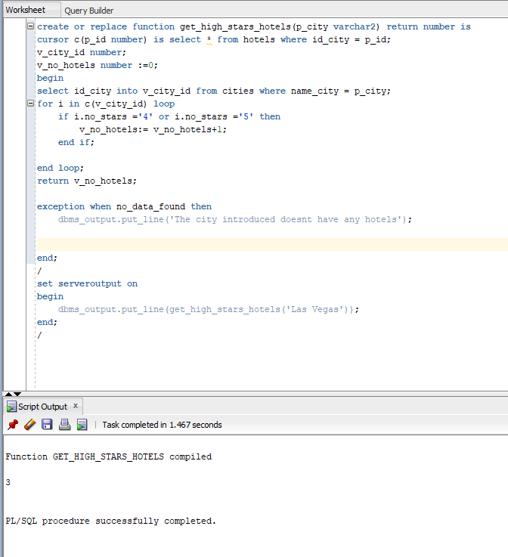

1. Write a trigger which doen't allow reservations that end in the next month (from the system date)

create or replace trigger block_reservations

before insert or update on reservations for each row

declare

begin

if :new.end_date between sysdate and ADD_MONTHS(sysdate,1) then

raise_application_error(-20002, 'Reservation are not allowed to end in the next month!');

end if;

end;

/

update reservations set end_date = TO_DATE('jul 02,2020','mon dd,yyyy') where id_reservation = 12;

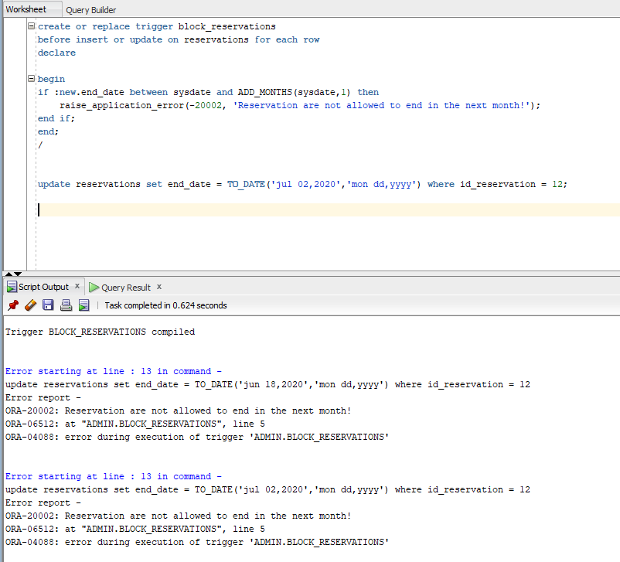

3.Given the PL/SQL block:

set serveroutput on

declare full_name varchar2(30);

begin SELECT first_name||last_name into full_name from emp where employee_id=&a; dbms_output.put_line(full_name);

end; /

Which of the following statement are true? a) A substitution variable is used b) A bind variable is used c) It shows the name and first name of employee 101 d) The block contains an error and doesn’t run e) The block includes conditional control

Rasp: a

4. Which of the following statements about packages are true?

a) The specs contain private objects b) The specs are mandatory c) The body is mandatory d) Can contain variables e) Can store overloaded subprograms

Rasp: b d e

5. Given this declaration part of a PL/SQL block

DECLARE TYPE tab_imb IS TABLE OF NUMBER;

t tab_imb := tab_imb(1,20,3,40,5);

[…]

Which of the following statement are true? a) An index by table variable is defined b) A nested table variable is defined c) A VARRAY variable is defined d) A composite type is defined e) A scalar type is defined

Rasp: b

6. Which of the following functions or statements can be used in PLSQL statements: a) CASE b) MAX c) COUNT d) GREATEST e) LEAST

Rasp: a, d, e

7. To run the statement needed to drop a table in PLSQL we need to use: a) EXECUTE IMMEDIATE b) DELETE c) DROP d) ALTER e) CALL For the first two exercises the database schema from the project will be provided in the Word file, together with the PLSQL code.

Rasp: a